Phase 2 - Fundamentals of Natural Language Processing
Natural Language Processing

Ramos Ruiz, Jerónimo
October, 2026

Abstract

Introduction
Natural language processing (NLP) is a subfield of computer science and artificial intelligence (AI) that uses machine learning to enable computers to understand and communicate using human language. It also enables computers and digital devices to recognize, understand and generate text and speech by combining computational linguistics, the rule-based modeling of human language together with statistical modeling, machine learning and deep learning. [1]
Among its most relevant applications are sentiment analysis and information retrieval, which support the interpretation of textual content and the efficient discovery of relevant information. However, each technique has a different approach to analyze text: one seeks to understand the "how is it said" (the emotion), while the other seeks to find the "what does it says" (the content).
Sentiment analysis (Also known as opinion mining) is an NLP task focused on identifying and classifying subjective information expressed in text, such as opinions, emotions, and attitudes. Depending on the application, sentiment analysis may involve assigning predefined categories to textual statements or discovering underlying patterns without previously labeled examples [2]. In this report we will be exploring both approaches.
In mental health-related contexts, these techniques can be applied to explore linguistic patterns and relationships between textual expressions and mental health categories. However, it is important to note that automated classifications should be interpreted with caution. This is because text alone cannot establish a clinical diagnosis or fully represent an individual's psychological condition, therefore a professional’s opinion is still necessary.
Information retrieval (IR), in contrast, focuses on identifying and ranking documents according to their relevance to a user's information needs. Traditional IR systems commonly rely on lexical representations and statistical weighting techniques, such as Term Frequency–Inverse Document Frequency (TF-IDF), combined with similarity measures to compare queries against documents. More advanced approaches incorporate semantic representations and machine learning to improve retrieval effectiveness. The evaluation of IR systems requires appropriate metrics, such as precision, recall, and F1-score, to measure their ability to retrieve relevant documents.
In this case, the CISI collection is a classic benchmark for information retrieval research, comprising 1,460 documents, 112 queries, and relevance assessments linking queries to relevant documents. Its structure makes it suitable for developing and evaluating retrieval systems under controlled conditions.
Unlike sentiment analysis, which focuses on identifying characteristics or categories within individual texts, information retrieval aims to identify documents that best satisfy a query. The CISI collection enables students to investigate how document preprocessing, term weighting, vector representations, and similarity measures influence retrieval performance.
Objectives
General objective
To design, implement, and evaluate Natural Language Processing techniques for sentiment analysis and information retrieval using the mental health corpus and the CISI benchmark collection, applying text preprocessing, feature representation, unsupervised and supervised learning, and quantitative evaluation methods to identify textual patterns, classify statements, and retrieve relevant documents effectively.
Specific objectives
- To apply appropriate text cleaning, normalization, tokenization, and feature extraction techniques to prepare both datasets for computational analysis.
- To identify potential patterns, similarities, and groupings among mental health-related statements without relying exclusively on predefined labels.
- To train and assess suitable machine learning algorithms using appropriate evaluation metrics
- To represent documents and queries using appropriate textual features and implement a retrieval method that ranks documents according to their estimated relevance to each query.
- To compare the performance of the implemented methods, discuss the influence of preprocessing and representation choices, identify methodological limitations, and formulate recommendations for potential improvements in sentiment analysis and information retrieval.
Methodology
- Sentiment Analysis on mental’s health dataset:
The "Sentiment Analysis for Mental Health" dataset from Kaggle used in this analysis consists of around 53.043 statements tagged with one of the following seven mental health statuses: Normal, Depression, Suicidal, Anxiety, Stress, Bi-Polar, and Personality Disorder.
The data is sourced from diverse platforms including social media posts, Reddit posts, Twitter posts, and more. Each entry is tagged with a specific mental health status, making it an invaluable asset for training machine learning models aimed at understanding and predicting mental health conditions based on textual data. [3]
Initially, the columns of interest are selected: the statements and the associated label in the status column. Subsequently, empty values ​​are removed from these columns to ensure the dataset contains no incomplete records. Regarding the statements, leading and trailing whitespace is removed, and empty and duplicated statements are eliminated.
Following data preprocessing, the number of records was reduced to 51,073; the texts had an average length of approximately 112.7 words, ranging from 1 to 6,300 words. Furthermore, the largest identified category was "normal states" (approximately 31.4%), followed by "depression" (29.5%) and "suicidal" states (20.8%), while the remaining states accounted for a smaller percentage.
For the unsupervised, lexicon-based sentiment analysis we used the VADER (Valence Aware Dictionary and sEntiment Reasoner) method since it is built for English and tuned on social-media text, which matches the Reddit/Twitter-style origin of this corpus. This model is tuned for informal wording, capitalisation, repeated punctuation and emoticons. Also, it is important to note that the model does not need to training data, it’s fast, and interpretable.
However, since the model is meant for general purpose, and distress is often expressed without any sentiment-bearing words ("I don't see the point anymore"), through sarcasm, or via clinical vocabulary absent from the lexicon; the results may need additional analysis before jumping into conclusions.
Although every row has a label, for the purposes of an exercise involving semi-supervised models, we will assume that only a small, random subset is labeled. Next, to train and evaluate a model, we will follow these steps:
- Randomly draw a labeled pool of 3000 documents. To split the data subsets, we use a stratification to ensure that the proportion of each class remains identical in both the training set and the test set.
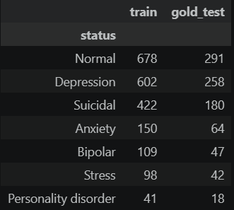
- Split the pool into two disjoint subsets: a training subset (labels used) and a gold-standard test subset. In this case, labels were used only for evaluation; during propagation they are hidden like the rest of the corpus.
- We assume that everything outside the pool is the unlabeled corpus. As mentioned before, its original labels are kept aside, and they are used only for extra validation.
- Finally, as an example, we will propagate the labels with three different methods using different models, then measure their accuracy on the gold test set. The models we are going to use are:
- SVC and logistic regression on the labeled subset and use it to label the remaining corpus.

Before training the models, we will use the TF-IDF interpretation using unigrams and bigrams fitted on the texts only. Also, the URLs are replaced by a `url` token. As for the stop-words, we will keep them in this way negations and first-person pronouns carry signal here.

Now for the tuning protocol of the models, we will not use the gold test set for tuning. In other hand, the train subset is split 70/30 training and testing respectively.

We pick the feature set (unigrams vs. unigrams+bigrams) and the regularization strength `C` / `alpha` by macro-F1 on the training subset. This decision was made because macro-F1 handles the class imbalance due to the size of the dataset.

- The second methodology was based on fine-tuning and semi-supervised retraining, employing the Label Spreading technique. Initially, three combinations of hyperparameters were evaluated—specifically regarding the number of nearest neighbors and the constraint factor (alpha), which controls the extent to which an original label can be altered.

Finally, once the optimal hyperparameter combinations for the model were determined, the labels were propagated from the training data subset to the remaining nodes.
- The final methodology used was focused on obtaining a conservative corpus by agreement. In this case, we assign, for every document, three predictions and keep the label only if at least two of the three methods agree.

Documents that do not achieve a 2-out-of-3 majority are discarded from the propagated corpus. We present the coverage (proportion retained) and precision for the resulting subset, which reflects the typical trade-off between precision and coverage.
Finally, having three different labeled corpus, we will train three different supervised models which are: Logistic Regression (strong, interpretable linear baseline for sparse text), Linear SVC (the SVC family; linear kernel is the standard choice for TF-IDF) and Complement Naïve Bayes (fast, designed for imbalanced text classes).
Additionally, we will present a Global view — feature importance, because, for the linear models the coefficients are directly interpretable: the largest positive coefficients of a class are the n-grams that push a document towards it. Also, we will present a local view (LIME) on three representative gold-test documents: the most confidently correct prediction for three different classes (preferring Normal, Depression and Suicidal, if present). LIME perturbs the text by removing words and fits a sparse local linear model to show which words push the prediction towards or away from the predicted class.
- Information retrieval with CISI:
The CISI collection is a classic benchmark for information retrieval research, comprising 1,460 documents, 112 queries, and relevance assessments linking queries to relevant documents. Its structure makes it suitable for developing and evaluating retrieval systems under controlled conditions [4] .
Conclusions and discussions
- Sentiment Analysis on mental health dataset:
At the initial Unsupervised, lexicon-based sentiment analysis we can see that VADER labels 54.8 % of the 51,073 statements negative, 12.3 % neutral and 32.9 % positive.
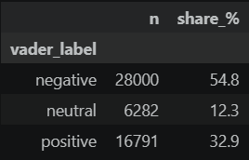
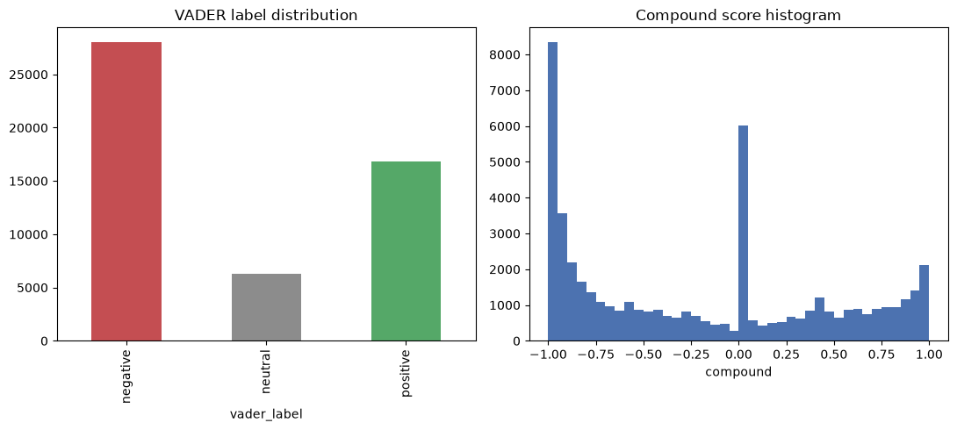
Although the mean composite score decreases monotonically according to the clinical severity of the label (suicidal tendencies: −0.44; anxiety: −0.36; depression: −0.33; stress: −0.26; bipolar disorder: −0.10; personality disorder: −0.06; normal: +0.10), the lexicon manages to capture a real, but imprecise, signal.
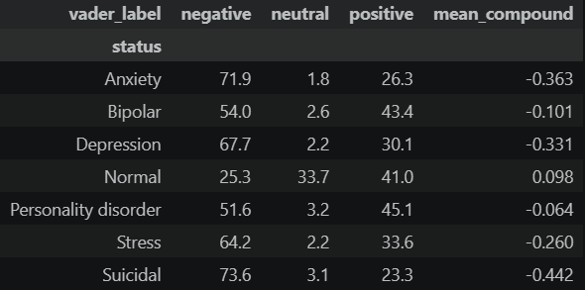
We can see that it fails often at the individual level: 31.7 % of all non-Normal statements are neutral/positive (about a quarter of Depression, Suicidal and Anxiety posts are labelled positive), while 25.3 % of Normal statements are labelled negative.
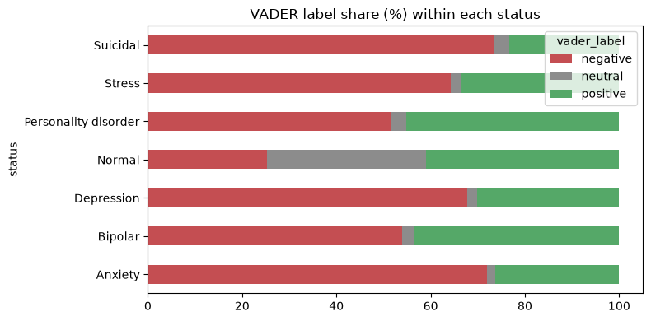
Some causes may involve implicit distress without sentiment words, narrative or clinical vocabulary missing from the lexicon, and positive words used in a negative context. We can conclude that the problem may not be by a few missing words, but that polarity is not the same construct as mental-health status.
On the 900-document gold test, logistic regression trained on the propagated corpus reaches accuracy 0.740 and macro-F1 0.684 (Linear SVC 0.736 / 0.680; Complement NB 0.646 / 0.537). Training on only the 2,100 labeled documents gives 0.730 / 0.655, and training on the original labels of the whole corpus gives 0.776 / 0.721.
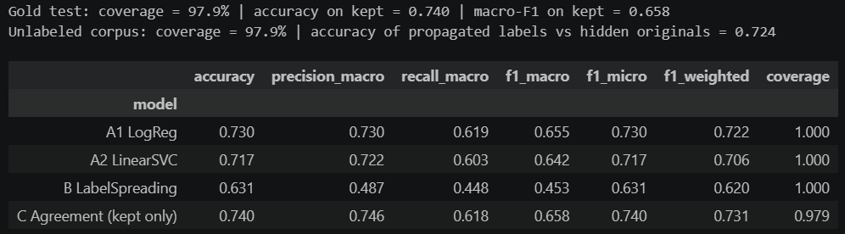
Propagation therefore recovers roughly a fifth of the accuracy gap and about two fifths of the macro-F1 gap, but the bootstrap 95 % intervals (accuracy [0.711, 0.769], macro-F1 [0.635, 0.727]) overlap with the lower bound, so the gain is suggestive, not statistically established.
Label spreading was the weakest labeler (0.631 / 0.453): the 100-d SVD keeps only ~18 % of the TF-IDF variance, so the k-NN graph is poorly informative, and the 2-of-3 agreement rule (97.9 % coverage) mostly reflects logistic regression and SVC agreeing. A better graph (more components, cosine on TF-IDF directly, or sentence embeddings) is the obvious improvement.
Per-class F1: Normal 0.88, Anxiety 0.77, Depression 0.69, Bipolar 0.67, Personality disorder 0.64 (only 18 test cases), Suicidal 0.63, Stress 0.51.
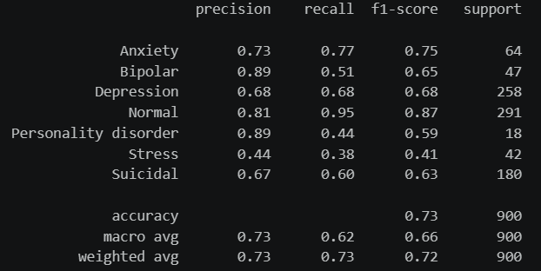
The two most frequent errors are Depression → Suicidal (50) and Suicidal → Depression (44), about 40 % of all 234 errors: the two classes share vocabulary and differ in degree of intent, which bag-of-words cannot measure. Suicidal → Normal (25 of 180, 14 %) is the clinically worst error type. Stress is confused with almost everything (recall 0.50), and Personality disorder is mostly absorbed by Depression (7 of 18).
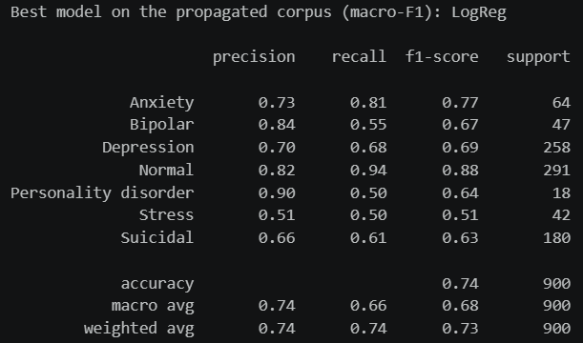
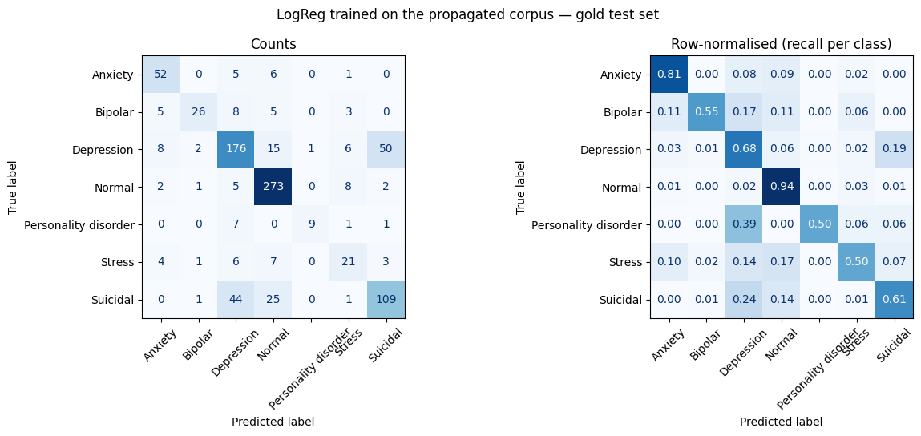
The largest coefficients are condition names, medications and symptom words for each class (anxiety/anxious/restless; manic/mania/lamictal/seroquel; die/suicidal/kill/cannot/myself; avpd/avoidant), while Normal is led by short conversational words.
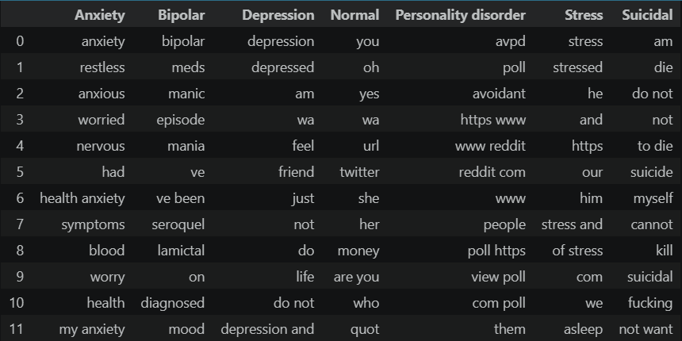
LIME on four gold-test documents confirms the pattern:
Depression (correct): "depression", "depressed", "anxiety", "my" push towards Depression, although the post lists several diagnoses (comorbidity), so the label is only one of several plausible ones.
Suicidal (correct): "die", "am", "not", "death" drive the prediction. First-person pronouns and negations/absolutes in suicidal language match findings in the literature on depression and suicidality, although the weights per word are small (≤0.06) because the evidence is spread over many features.
Normal (correct): the example is a two-word message; every LIME weight is ≈0, i.e. the model defaults to the majority/"chat-like" class when there is no clinical vocabulary, which is why Suicidal → Normal errors occur for implicit or indirect expressions.
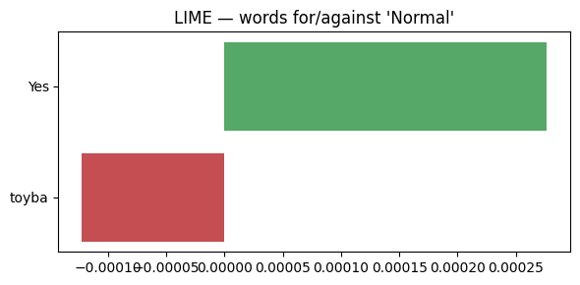
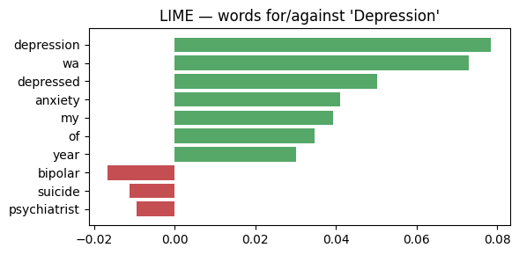
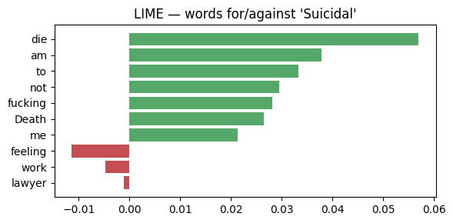
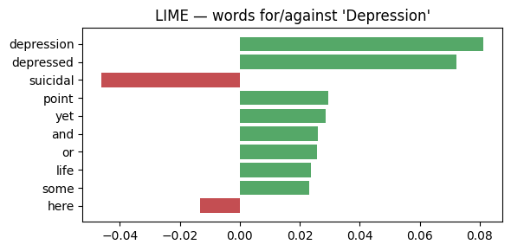
Error case (true Suicidal, predicted Depression): the author writes that they do not feel depressed but do not want to live. "depression"/"depressed" add +0.08/+0.07 towards Depression, and "suicidal" counts against it: a bag-of-words model has no notion of negation scope, so it follows the surface vocabulary and misses the meaning.
It is important to note that:
The classes seem to be partly separated by their origin (explicit condition names and medications, community-specific terms such as "avpd", conversational chat for Normal), so the 74 % accuracy probably overstates generalization to texts from other platforms.
The texts appear to be pre-processed upstream (tokens like "wa" from "was", "ve" from "I've"): "wa" is a high-weight feature, an artefact, not a signal.
The gold test is small for the rare classes, hence the wide intervals.
These models are educational and must not be used to screen or make decisions about people.

Exercise 2:
• According to the evaluation results, is your IR model ready to be deployed in an organizational context? How close is it to the relevance judgments?
• What additional elements are worth highlighting regarding the process, results, or models used (e.g., robustness, computational cost, ease of interpretation)?

